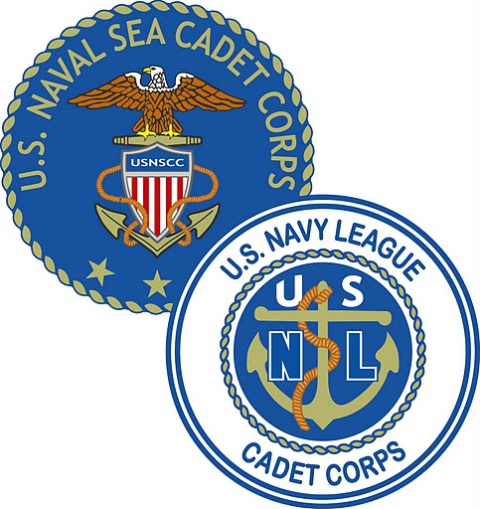 | U.S. NAVAL SEA CADET CORPS | 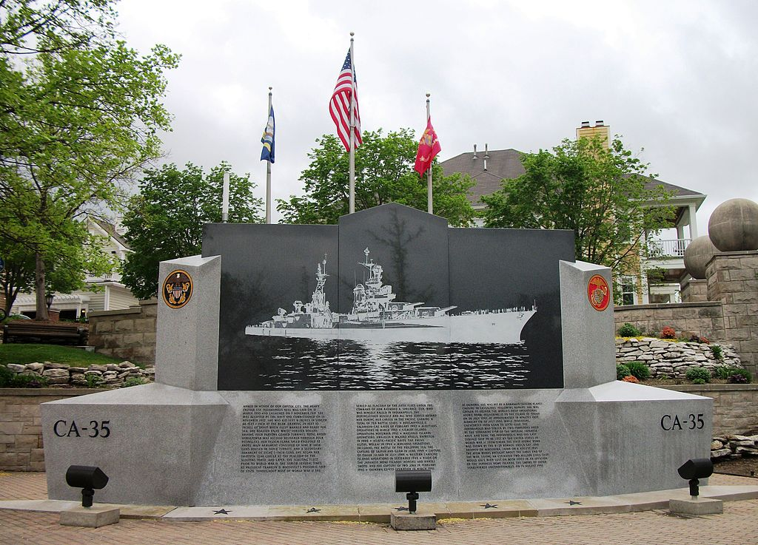
USNLCC Training Ship Indianapolis
Phoenix Arizona
P: (623) 341-4980 chollaskipper.wix.com/Indianapolis

PLAN OF THE DAY
The Plan of the Day is an official document of USNSCC George Horvath Division & USNLCC Training Ship Indianapolis. Its contents reflect current orders of the Commanding Officer and official unit announcements. All Division personnel are responsible for reading and understanding the information contained herein. Parents and guardians of Cadets are encouraged to read the Plan of the Day and to make note of meeting days and special announcements that may affect personal schedules.

22 April 18 - SUNDAY
LT Lori Bykerk
NSCC Commanding Officer
623-341-4980
Ensign Nicholas Wheeler  NSCC EXECUTIVE OFFICER  480-229-6065 |  |  |  | ABC/LC3 Amelia Cooney APC/LC2 Cecil Brower  NLCC LPO NLCC APOC  623-878-0402 928- 830-6948
Drill Hours: | Saturday 0745 – 1600  Spirit of Hope United Methodist Church  14403 N. 75th Avenue  Peoria, AZ 85381 REMEMBER: DRILLS ARE MANDATORY. FOLLOW YOUR COC  TO INFORM IF YOU ABSOLUTELY CANNOT BE AT DRILL!
UNIFORM OF THE DAY: | Officers/CPOs: |  | ATTENTION TO ORDERS:  Arrive in: Khaki’s, NWUs/CUUs or Instructor Attire, PT Gear
 | Cadets: |  | Arrive in: CUUs, change into PT Gear
DRILL ROUTINE
0730 – 0745 - Arrive at drill site  0745 – 0800 - Muster and TURN IN COURSEWORK at Quarterdeck  upon arrival!  0800 - 0815 - Colors  0815 - 0830 - Commander’s Address  0830 – 0900 - Change into PT Gear  0900 – 1100 - Self defense training with guest instructor  1100 - 1200 - PT Qualifications  1200 - 1245 - Chow with special video, sweepers  1245 - 1315 - Change into CUUs  1315 - 1400 - Coursework, promotion testing, rotating through supply  1400 - 1445 - Classroom training with guest speaker  1445 - 1530 - Close order drill & knock out drill  1530 – 1600 - Sweepers with inspection  1600 Secure from drill - LIBERTY  Reminder: We always have visiting families/potential cadets on deck. Be mindful of your behavior, actions and attitudes. Poor attitudes need to be left at the door because when are on duty, it is all business. |  |  |  |  | DRILL:  Be responsible! (meaning you are  able to choose your response)  Take care of & discipline yourself so others don't have to!!!  Bring your lunch  You MUST eat breakfast before drill.  Healthy snacks and hydration required!  YOU MUST HAVE:  PROPER HAIRCUT- NO EXCEPTIONS!  Pen/Paper/Hydration  SUNSCREEN IS MANDATORY
This is a mandatory event! Cadets are expected to arrive in the Uniform of the Day to participate in activities. Ensure you have pen/paper/BJM with you!
For more information, contact your COC or go to the website: chollaskipper.wix.com/Indianapolis. If you can't make it to Drill or are going to be late, notify your COC early! Failure to notify will be considered AWOL(Absent Without Leave) and will have negative consequences!!!! Arrive early to ensure you don't miss out on Drill Activities. Remember, if you're not having fun, you're doing it wrong!

As ordered by: LT Lori Bykerk
NSCC Commanding Officer

NOTES:

